1. Evaluation indicators: (single device and multiple devices)

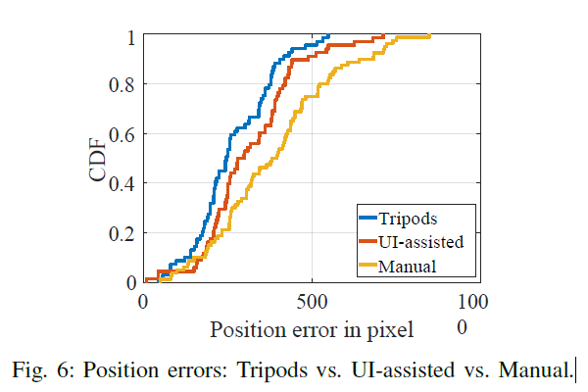

In this part I hope that the yellow curve can be turned into an evaluation under free rotation, and the result is better than that of the tripod.

1. Angular accuracy (azimuth error, elevation error) and positional accuracy (pixel error)

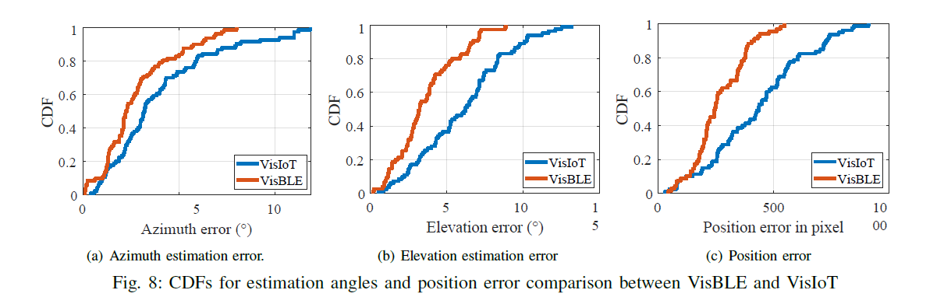

Similarly, this part is also expected to be an error comparison after the device rotates freely.

You can also add a set of average CDF curves for multiple devices.

1. The curves of the above three errors changing with the test distance (1-6m)

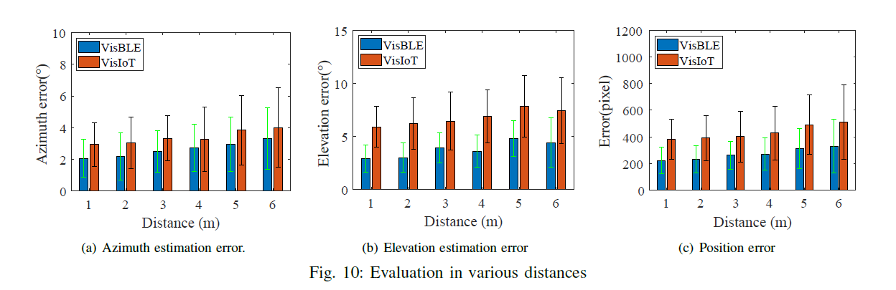

Same as above.

1. The position corresponding to a single device or multiple devices in the actual visual map (the visual scene is more general, preferably a desk)

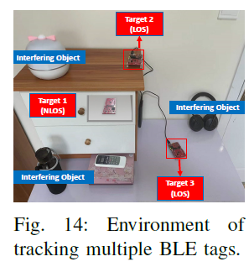

Remove tripods and bottle, and add new Bluetooth devices and interference devices.

1. Variation of positioning accuracy with acquisition time
2. Changes in positioning accuracy as the number of devices increases

This part can be combined with the second experiment.

1. Comparison between the angle of the level test and the real angle
2. The accuracy of device identification and the degree of matching with AOA

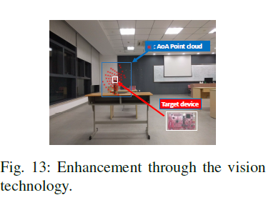

In this part, I expect that in Experiment 4, the corresponding AOA point cloud can be added，such as this picture.

1. Resource evaluation (acquisition time, calculation time, power calculation, evaluation of mobile phone power loss)

Add picture: Take the picture of new equipments, such as below.

